Directions: The goal of the following problems is to help challenge and deepen your understanding of the current topic. Don’t assume that you will know how to answer each and every question. You will work with at least two other students in the class to try and find solutions and write arguments for each of the following questions. Be sure that you question your classmates’ reasoning. If you don’t understand how they are getting something you should ASK THEM TO EXPLAIN! Being able to defend your reasoning is important and so you are actually helping them by asking them to explain.

Challenge Questions
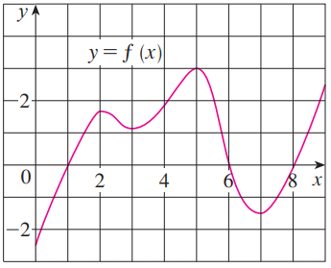
- The graph of a function is shown at the right. Assume that the domain of is . Use the graph of the function to help answer the following questions.
- On what intervals is f increasing? Decreasing?

Increasing:
Decreasing:

- At what values of x does f have a local maximum? Local minimum?

Local minimums occur at
Local maximums occur at

- Estimate on what intervals is f concave upward? Concave downward?

Concave upward:
Concave downward:

- Estimate the x-coordinate(s) of the point(s) of inflection.

Inflection points occur at

- Consider the function . Without the use of a graph, determine each of the following.

We calculate and
We see that when . is never undefined.
We see that when . is never undefined.
- On what intervals is f increasing? Decreasing?
$$-$$
$$+$$
$$+$$
$$MIN$$

Increasing:
Decreasing:

- At what values of x does f have a local maximum? Local minimum?

Local maximum: None
Local minimum occurs at .

- On what intervals is f concave upward? Concave downward?

$$+$$
$$-$$
$$+$$
Concave up:
Concave down:

- State the x-coordinate(s) of the point(s) of inflection.

Inflection points occur at .

- Suppose the derivative of a function is .
- Determine where is increasing and decreasing, if you assume that is defined on .

We see that when
is undefined when .
$$-1$$
$$-2$$
$$1$$
$$-$$
$$-$$
$$+$$
$$-$$
$$MAX$$
$$MIN$$
$$MIN$$
$$0$$
$$+$$
$$3$$
$$6$$
$$+$$
$$+$$

Increasing:
Decreasing:
- Determine at what x-values has local extrema.

A local maximum occurs when .
Local minimums occur when

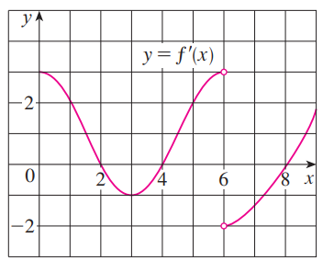
- The graph of the derivative of is shown below.
- On what intervals is f increasing? Decreasing?

We know that f is increasing when and is decreasing when .

Therefore we find that f is
Increasing on
Decreasing on

- At what values of x does f have a local maximum? Local minimum?

Local maximums will occur when or is undefined and switches from positive to negative. Similarly for local minimums, except that needs to switch from negative to positive. We can also consider endpoints.

Local maximums occur at
Local minimums occur at

- On what intervals is f concave upward? Concave downward?

We need to look at slopes of tangent lines on to determine this. When these slopes are positive will be concave up and when they are negative will be concave down.

Concave up:
Concave down:

- State the x-coordinate(s) of the point(s) of inflection.

The concavity switches when and so this is the only spot where an inflection point occurs.

- Use the information that you have to create a possible picture of .

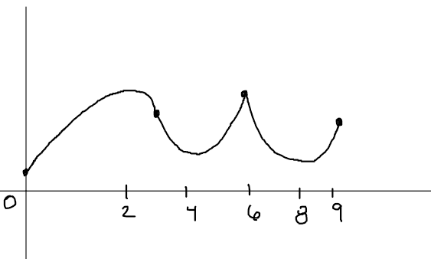

- Find the local maximum and minimum values of using both the First and Second Derivative Tests.

We calculate that
when
is undefined when

$$undefined$$
$$-$$
$$+$$
$$MIN$$

So by the First Derivative Test there is a local minimum at .
This local minimum value is .
There are no local maximum values.

We calculate
We test the value of when . We can clearly see that .
Therefore is concave up when and so we can confirm that there is a local minimum at .
- Suppose that , , and and for all x.
- Sketch a possible graph for f.

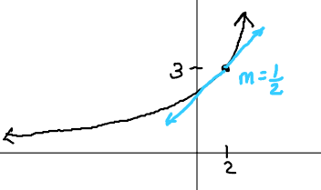

- How many solutions does the equation have? Why?

Since we know that for all x, then can only cross the x-axis at most one time. Note that if exists entirely above the x-axis then there will be 0 solutions, but if starts below the x-axis, then there could be 1 solution.

- Is it possible that ?

We can clearly see that would satisfy the condition that .
Since for all x, this means that is increasing for all values of x. Therefore, it must be the case that . Since this condition hasn’t been violated.

It is therefore entirely possible for .

- Consider the function .
- Determine the exact value of x at which increases most rapidly. Hint: Something is being maximized here. What function are we trying to maximize?

If we want to find when increases most rapidly we are looking for the time when has a tangent line with the largest slope. This means that we actually need to maximize .

We compute that .
To maximize this function we need to find its derivative and then progress through the normal techniques of finding maximums.
We compute
.
when
is never undefined.

We put these values on a number line and check for where there are maxes and mins.
$$+$$
$$-$$
$$+$$
$$MIN$$
$$MAX$$

It appears that there is local maximum at but we cannot be sure that values after end producing even larger values.

We check the to see the end behavior of the graph.
This is interesting because it means that the function is increasing after up until the y-value of 0. Note that the function cannot go past this y-value otherwise it would have to decrease, and we note that the function only increases past .

This means that there must be an absolute maximum value at .

- Reflect on your work in part (a). What does your work here imply about the significance of inflection points?

We can see that there is an inflection point on at and this corresponds to the point at which increases most rapidly. So, in general inflection points are points on function where that function can potentially be increasing or decreasing most rapidly.

- Consider the function , where a, b, c, & d are real numbers with .
- Prove that has exactly one inflection point.

We calculate that and .
Clearly when .
is never undefined.
We then test the concavity on either side of this value.
We test at the values of and .
We see that
and

Clearly the concavity changes at this point and therefore it must represent an inflection point.
So has exactly one inflection point at .

- Prove that if has 3 x-intercepts, then the inflection point occurs at the average value of the intercepts.

Suppose that is an x-intercept of . This means that is divisible by .
We continue with a polynomial long division.

Since we know that must divide then this remainder must equal 0.

So we can write
Then by the Quadratic formula we know that and we know that this must represent two different real number values since is given as having 3 roots.

Now we can find the average of the 3 different x-intercepts that we have found.

- Use the result to from part (b) to find the inflection point of the cubic polynomial , and check your result by finding the inflection points of using the second derivative.

We note that .
This means that has x-intercepts of .
We calculate the average of these x-intercepts to be and so we believe that has an inflection point at .

We check this by computing .
Clearly when .
is never undefined.
We test to see if corresponds to an inflection point.
$$-$$
$$+$$

We test and and confirm that this is the case.
Since the concavity changes at , there is an inflection point here.

- For what value c is the function increasing on .

We calculate that .

For this function to be increasing we need .
So, if we can determine the minimum value of then we will know what value(s) c can be.
Let .
We calculate that
is never undefined.
when .

So the local minimums of occur at and are and .

However, since we notice that
and
we can say that must be the absolute minimum value of the function.
Therefore, as long as then and thus which implies that meaning that will be increasing for all values of x.

